Collection

1. Collection Framework
Definition
Set of interfaces and classes used to store and manipulate data.

Hierarchy

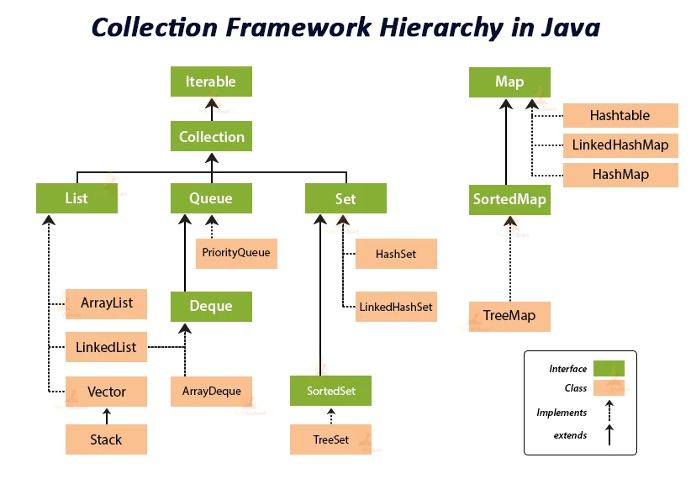

Iterable
Root interface, supports for-each loop.
iterator()

Collection
Parent interface of List, Set, and Queue.
add()
remove()
contains()
size()

Important
- Collection → Interface
- Root Interface → Iterable
- Map is not part of Collection
- Primitives not allowed

2. List
Yes, include all implementations:
List is an interface that defines rules such as insertion order, duplicates, null values, and index-based access. The actual data is stored by implementation classes like ArrayList, LinkedList, Vector, and Stack.
Or even shorter:
List is an interface that defines rules for storing data. ArrayList, LinkedList, Vector, and Stack implement these rules and store the actual data.

ArrayList

Definition
ArrayList is a class that implements the List interface using a dynamic array.

Follows List Rules
Order ✅
Duplicate ✅ Unlimited
Null ✅ Unlimited
Index ✅

Internal Working
[Rahul][Amit][Neha][null]
- Uses a Dynamic Array internally
- Fast access using index → O(1)
- Slow insert/delete in middle → Elements shift

Default Capacity
ArrayList<String> list = new ArrayList<>();
Default Capacity = 10
(Array is allocated when the first element is added.)

Resize Formula
When full, capacity increases by 50%.
newCapacity = oldCapacity + (oldCapacity / 2)
Example:
10 → 15 → 22 → 33 → 49

Interview One-Liner
ArrayList is a dynamic array implementation of List that maintains insertion order, allows unlimited duplicates and null values, supports index-based access, provides fast retrieval, and grows automatically by 50% when full.

import java.util.ArrayList;
public class Main {
public static void main(String[] args) {
ArrayList<String> list = new ArrayList<>();
list.add("A"); // O(1) amortized
list.add("B"); // O(1) amortized
list.add(1, "X"); // O(n) - elements shift right
// [A, X, B]
list.get(0); // O(1)
list.set(1, "C"); // O(1)
list.contains("A"); // O(n)
list.remove(0); // O(n) - elements shift left
// [C, B]
list.size(); // O(1)
for (String s : list) { // O(n)
System.out.println(s);
}
}
}

LinkedList

Definition
LinkedList is a class that implements the List interface using a doubly linked list.

Follows List Rules
Order ✅
Duplicate ✅ Unlimited
Null ✅ Unlimited
Index ✅

Internal Working
Head
↓
[Rahul] ⇄ [Amit] ⇄ [Neha] ⇄ [null]
↑
Tail
Each node contains:
Data
Previous Reference
Next Reference
Example:
[Amit Node]
Data = Amit
Prev = Rahul
Next = Neha

How get(2) Works?
list.get(2);
Internally:
Rahul → Amit → Neha
Traverses node by node until index 2.

How Insert Works?
Before:
A ⇄ B ⇄ C
Insert X:
A ⇄ X ⇄ B ⇄ C
No shifting.
Only references are updated.

How Delete Works?
Before:
A ⇄ B ⇄ C
Remove B:
A ⇄ C
Again, only references are updated.

Performance
get() O(n)
add() O(1)*
remove() O(1)*

Interview One-Liner
LinkedList is a doubly linked list implementation of List that maintains insertion order, allows unlimited duplicates and null values, supports index-based access, stores data in nodes connected by previous and next references, and provides fast insertion and deletion without shifting elements.
How does LinkedList increase its size?
LinkedList does not resize like ArrayList or Vector. Every new element creates a new node and connects it using references, so there is no capacity or resize formula.

import java.util.LinkedList;
public class Main {
public static void main(String[] args) {
LinkedList<String> list = new LinkedList<>();
list.add("A"); // O(1) at end*
list.add("B"); // O(1) at end*
list.addFirst("Start"); // O(1)
list.addLast("End"); // O(1)
list.get(1); // O(n)
list.set(1, "X"); // O(n)
list.contains("A"); // O(n)
list.removeFirst(); // O(1)
list.removeLast(); // O(1)
list.size(); // O(1)
for (String s : list) { // O(n)
System.out.println(s);
}
}
}

Vector

Definition
Vector is a class that implements the List interface using a dynamic array and is synchronized (thread-safe).

Follows List Rules
Order ✅
Duplicate ✅ Unlimited
Null ✅ Unlimited
Index ✅

Internal Working
[Rahul][Amit][Neha][null]
- Uses Dynamic Array internally
- Thread Safe (synchronized)
- Fast index-based access

Default Capacity
10

Resize Formula
newCapacity = oldCapacity * 2
Example:
10 → 20 → 40 → 80 → 160

Key Difference from ArrayList
ArrayList : old + (old / 2)
Vector : old * 2
Example:
ArrayList : 10 → 15 → 22 → 33
Vector : 10 → 20 → 40 → 80

Interview One-Liner
Vector is a thread-safe dynamic array implementation of List that maintains insertion order, allows unlimited duplicates and null values, supports index-based access, and doubles its capacity when full using newCapacity = oldCapacity * 2.

Quick Revision
ArrayList : old + (old / 2)
Vector : old * 2
LinkedList: No Resize
New Node Created

import java.util.Vector;
public class Main {
public static void main(String[] args) throws InterruptedException {
Vector<Integer> vector = new Vector<>();
vector.add(10); // O(1) amortized - synchronized method (thread-safe)
vector.add(20); // O(1) amortized - synchronized method (thread-safe)
Thread t1 = new Thread(() -> vector.add(1)); // synchronized add()
Thread t2 = new Thread(() -> vector.add(2)); // synchronized add()
t1.start();
t2.start();
t1.join();
t2.join();
System.out.println(vector); // [10, 20, 1, 2] or any order
}
}
Output (order may vary):
[10, 20, 1, 2]
or
[10, 20, 2, 1]

Stack

Definition
Stack is a class that implements the List interface (through Vector) and follows the LIFO (Last In First Out) principle.

Follows List Rules
Order ✅
Duplicate ✅ Unlimited
Null ✅ Unlimited
Index ✅

Internal Working
Top
↓
30
20
10
- Last element added is removed first.
- Internally Stack extends Vector.
- Uses a Dynamic Array internally.

Operations
push(10); // Add
push(20);
push(30);
pop(); // Remove 30
peek(); // View 20

LIFO
push(10)
push(20)
push(30)
Top
30
20
10
pop()
Top
20
10

Capacity Growth
Since Stack extends Vector:
Default Capacity = 10
newCapacity = oldCapacity * 2
Example:
10 → 20 → 40 → 80

Interview One-Liner
Stack is a LIFO data structure that extends Vector, maintains insertion order, allows unlimited duplicates and null values, supports index-based access, and doubles its capacity when full.

Memory Trick
ArrayList = Fast Read
LinkedList = Fast Insert/Delete
Vector = Thread Safe
Stack = LIFO

import java.util.Stack;
public class Main {
public static void main(String[] args) {
Stack<Integer> stack = new Stack<>();
stack.push(10); // O(1)
stack.push(20); // O(1)
stack.push(30); // O(1)
System.out.println(stack); // [10, 20, 30]
System.out.println(stack.peek()); // O(1) -> 30 (top element)
stack.pop(); // O(1) -> removes 30
System.out.println(stack); // [10, 20]
System.out.println(stack.search(10)); // O(n) -> position from top
System.out.println(stack.isEmpty()); // O(1)
}
}
Key Methods:
- push() → add element (top)
- pop() → remove top element
- peek() → view top element

